2021-02-22 Group 2 (5-6) 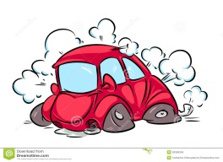
Read the extracts below and fill in the gaps with the linking words and phrases.
At first, and, As soon as, then, Suddenly, before, As
1) ………… I arrived at the supermarket I got a trolley and started doing my shopping. It took me about an hour 2) …………I reached the till. 3) ……..two men entered and ran towards the cashier. 4) ……… I thought they were some friends of hers but 5) …………. I realized they were robbers. They asked us to get down on the ground and asked the cashier to give them the money she had. 6) …………… the cashier was putting the money in a bag we heard a police siren. The men panicked, dropped the bag 7) ………… ran toward the exit. The police officers arrested them and took them to the police station.
but, then, As, Suddenly, so, At first, For a few minutes
1) ………….. I was driving home, it started to snow. The road became dangerous. 2) …………… a deer ran out of the forest and into the road. It was too late to change the direction of the car, 3) ……………. we hit it. I stopped the car and got out. The deer lay in the road. 4) ………….. I thought it was dead, 5) ………….it opened its eyes. 6)………..it stood still, 7) ………it walked back into the forest.

