Group 2 (5-6) 2021-01-11

The legend of Vilnius

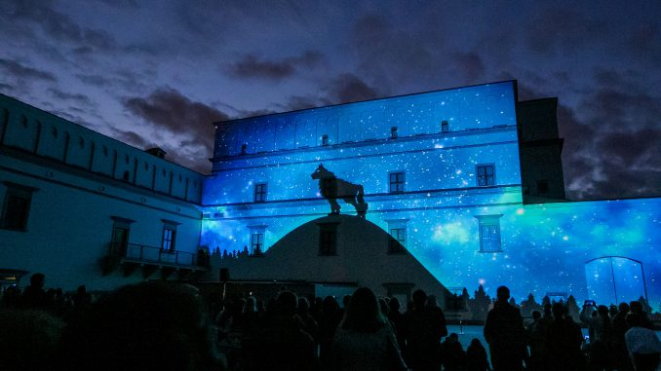
____________, one of the most beautiful cities near Vilnius in the Baltic States, was the first capital of Lithuania and the home of Grand Duke ___________ in the 14-th century. One day, Gediminas, went on a hunting trip about 20 kilometres away from Trakai. For everyone’s fortune, the trip was successful and ______________ killed the aurochs, the biggest ___________ in Lithuania. Gediminas decided to camp in the woods at Šventaragis’ valley. While he was asleep, Gediminas had an usual ____________ in which he saw an iron ____________ at the top of the mountain. In the morning the Duke asked the pagan priest _____________ to explain the dream. He told the Duke that the dream was a direction to found a city among these hills and the howling of the wolf represented the fame of the future city. So the Grand Duke of _______________, immediately started to _______________ the future capital, and it took the name - ________________ - from the stream of Vilnia.

