Group 1 (3-4) 2021-01-04 Culture Corner
This is 10 Downing Street in London. It’s the British Prime Minister’s home. People often call it just “Number 10”. It’s actually a very big house. There are a hundred rooms in it.
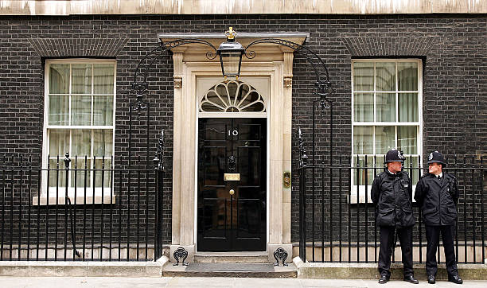
Whose home is this? Not a real person’s. But the house is real. It’s 221b Baker Street in London, and it’s the home of the famous detective, Sherlock Holmes. Today it’s a museum about him.
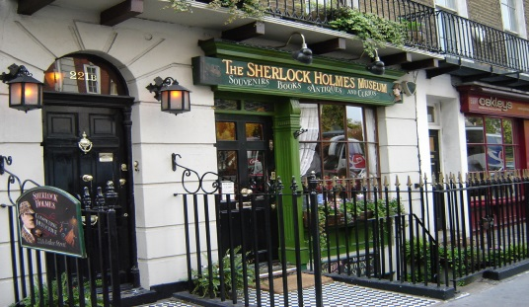
Abbey Road is in London, too. Why is it famous? It’s on the Beatles’ album “Abbey Road”. The crossing is outside their recording studio at 3 Abbey Road. There is a webcam there now, so you can see it on your computer.
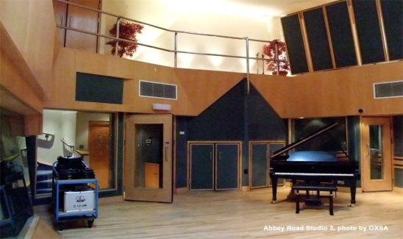
Penny Lane is also famous because of The Beatles. It’s the name of one of their songs. Do you know it? Penny Lane isn’t in London. It’s in Liverpool. The Beatles were from Liverpool.
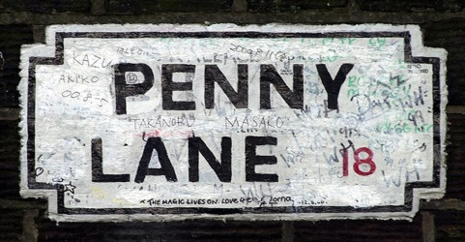
Address | Where is it? | Why is it famous?
1. 10 Downing Street
2.
3.
4.

Complete the dialogues with questions.
1. ____________________?
My name’s Tom Potter.
2. _____________________?
I’m from Scotland.
3. _____________________?
It’s for my brother.
4. ______________________?
Oscar.
5. ____________________?
He’s eleven.

