Group 2 (5-6) 2020-12-21 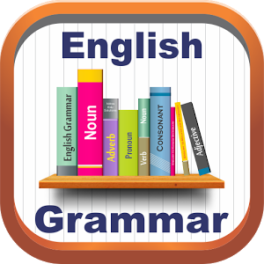
1. Match the adjectives below to make pairs of opposites.
awful different difficult expensive fantastic good large low new safe true wrong
1. bad ____________ 7. terrible ___________
2. great ___________ 8. high _____________
3. similar__________ 9. old _____________
4. easy ___________ 10. right __________
5. cheap __________ 11.dangerous _________
6. false ___________ 12.small _____________
2. Complete the adjectives. Use a,e,i,o,u and y.
1. fr _ _ ndl _ 5. us _ f _ l
2. k _ nd 6. n _ c _ ss _ r _
3. h _ pp _ 7. c _ mf_ rt _ bl _
4. t _ d _
3. Circle the words that are different.
1. boots scarf shoes
2. cardigan jumper skirt
3. coat jacket shorts
4. dress jeans leggings
5. cap socks hat
6. tie tracksuit trainers
4. Put the sentences in the correct order to make a conversation.
Going to the airport
A. She has got long blonde curly hair. She is medium height, has a round face and blue eyes. She is going to have a pink suitcase and her name is Sally.
B. I can pick her up, no problem! What does she look like?
C. You’re welcome! See you later!
D. No, I’m not. Why do you ask?
E. Hi, Janet! Are you busy today?
F. With the pink suitcase I can’t miss her!
G. I have to work, but my sister is coming into the town. I need somebody to pick her up at the airport.
H. Thank you so much. Janet, you are the best!

1. | E
2.
3.
4.
5.
6.
7.
8.

