Group 5-6
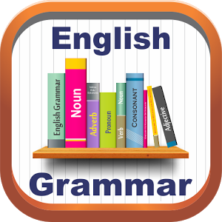
1. Fill in: a or an.
1……atlas 2 …… pen 3……..timetable
4……apple 5……school 6……orange.
2. Write the correct pronoun.
1. classroom - it 2. guitars -.......... 3. Jane -..........
4. Emma and Clara-.......... 5. Ronaldo-..........
3. Fill in: am, is, are
1. We…….eleven years old.
2. Tim …….eighteen.
3. My friends ……nice.
4. I……from Lithuania.
5. She…….in class 5
4. Fill in : have or has
1. I…… got a sister.
2. Ann ….. got a ruler.
3. He………got a skateboard.
4. They….. got many friends.
5. Batman……got a cloak.
5. Put the words into the correct order:
1. this/ a/ is/ ruler.
2. lesson/ where/ the/ is/ Maths?
3. has/ a/ got/ camera/ he?
4. friend/ Ann/ is/my.
5. have/ a/ I/ got/ not/ ruler.
6.Underline the odd word:

1. Sunday Tuesday Monday October
2. Maths pen Science Geography
3. I is he she
4. France English the UK the USA
7.Choose the correct item:
1. This is .......... egg.
A. an B. a C. -
2. My sister and my brother .......... 18 years old.
A. `m not B. isn`t C. aren`t
3. This is my schoolbag. .......... is red.
A. It B. She C. He
4. There .......... a park near my house.
A. are B. aren`t C. is
5. Look at these ..........
A. woman B. women C. womans
6. Lisa .......... got a big house.
A. have B. has C. haves
7. My flat is on the .......... floor.
A. three B. third C. thirteen

