Put the words in the correct order. 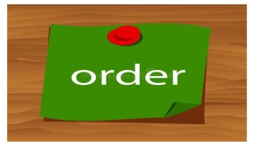
1. plays / with/ me / tennis / cousin / usually / my / .

________________________________________________________________________________

- a / is/ good / sister / very / basketball / John’s / player / .

________________________________________________________________________________

- to / always / Sundays / on / dad / swimming pool / the / goes / my / .

________________________________________________________________________________

- the phone/ in the middle of the night/ woke / me/ up/.

________________________________________________________________________________

- ninth / happens / what / on / April / of / the / ?

________________________________________________________________________________

- is / what / weather / like / the / spring / in / ?

________________________________________________________________________________

- didn’t / hair / baby / I / a / have / was / I / any / when / .

________________________________________________________________________________

- were / any / trains / ago / there / hundred / two / years / ?

________________________________________________________________________________

- cousin / my / I / to / visit / am / going / in / summer / .

________________________________________________________________________________

- drank/ we/ juice/ very/ quickly/ our/ orange/.

________________________________________________________________________________

