Across

Down

1.  3. 

1

2

3

4

5

6

7

8

9

10

11

12

13

14

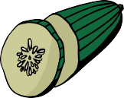2. 5.

9.  10. 

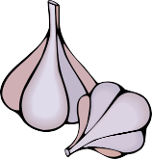12. 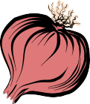 13.

14. 

4.  6. 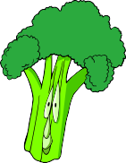

7. 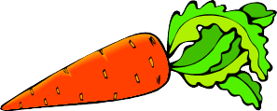

8. 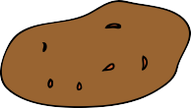 11. 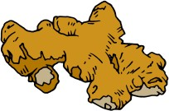

# Answer Sheet

|  |  |  |  |  |  |  |  |  |  |  |  |  |  |  |  |
| --- | --- | --- | --- | --- | --- | --- | --- | --- | --- | --- | --- | --- | --- | --- | --- |
|  | | | | |  |  |  |  |  |  |  |  |  | | |
|  | E | G | G | P | L | A | N | T |  |  |
|  | M |  |  |  |  |  |  |  |  |  |  |  |  |  |  |
|  | U |  |  |  |  |  |  |  |  |  |  |  |  |  |  |
|  | S |  |  |  |  |  |  |  |  |  |  |  |  |  |  |
|  | H |  |  |  |  |  |  |  |  |  |  |  |  |  |  |
|  | R |  |  |  | C | H | I | L | I | P | E | P | P | E | R |
|  | O |  |  |  |  |  |  |  |  |  |  |  |  |  |  |
|  | O |  |  |  |  |  | G |  |  |  |  |  |  |  |  |
|  | M |  |  |  |  |  | I |  |  |  |  |  |  |  |  |
|  |  |  |  |  |  |  | N |  |  |  |  |  |  |  |  |
|  |  |  |  |  |  |  | G |  |  |  |  |  |  |  |  |
|  |  |  |  |  |  |  | E |  |  |  |  |  |  |  |  |
|  |  |  |  |  |  |  | R |  |  |  |  |  |  |  |  |