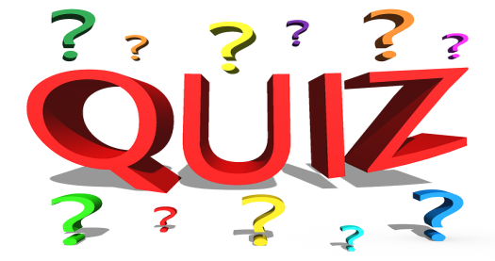

Rearrange the letters in the following words to understand what they are.

0 | REHTOM,ONS,NUAT | Mother, son, aunt | Family
1 | NIONO,BUCURECM,OTTAPO
2 | IGNIND, R’SILHENCD,GIVNLI
3 | UGUSAT,MEREBDEC,LUJY
4 | RUSYTHAD, DEWENYSAD, RYIFAD
5 | RATSHEM, NASEK, HERA
6 | LYBECIC, NAPEL, POCLEHIRET
7 | CAJTEK,SRAFC,SGOVEL
8 | HETACRE, SUMICANI, TASRUTAON
9 | PSIHLO, PSISHAN, SCEHNEI

