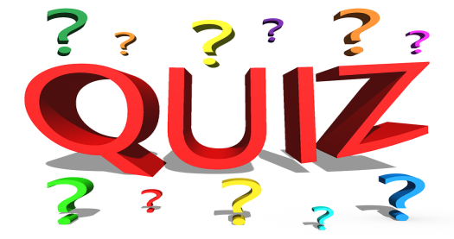
Look at this list of words. Each word is a capital, a holiday or a famous place of interest. Can you put the words in the correct group? There are more words than you need.
Washington New York the Statue of Liberty Dublin
The Mississippi Big Ben London Thanksgiving Day
Hollywood Westminster Abbey Guy Fawkes’Day the British Museum
Bank holidays The Tower of London the Eiffel Tower
Country | Capital | Holidays | Places of interest
England | 1. | 1.  2. | 1. Big Ben  2.  3.  4.
The USA | 1. | 1. | 1.  2.

