Task 1.
You know that there are 26 letters in the English alphabet. Do you remember all of them?
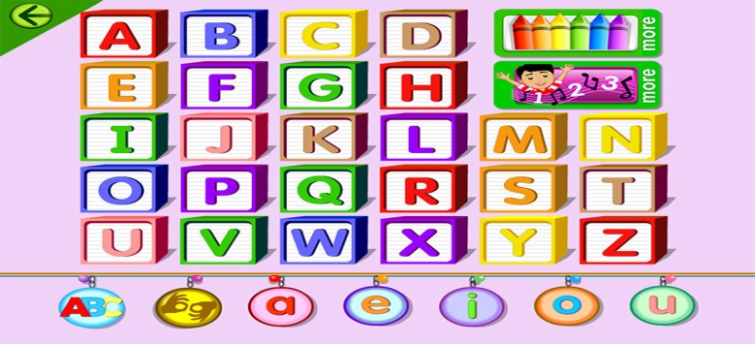
Complete the sentences with the words whose first letters make ABC. Some letters are given to you:
1. My father’s sister is my aunt.
2. My father’s son is my ……..
3. What time does the bank c….?
4. Every evening I write in my d…..
5. Have you got any e……….?
6. There are 5 ……on my hand.
7. You can g….off the bus at this stop.
8. When do you ……dinner?
9. All children like i……..
10. All of us hate traffic ….!
11. I’m sorry, I don’t k… your name.
12. We all ……..at school.
13. My mother is a ……., she plays the piano.
14. We usually sleep at n…..
15. Banks … at 9:00 in Lithuania.
16. We can buy stamps at the …… office.
17. It’s a ………to seven.
18. A lot of people r……bicycles in Lithuania.
19. My brother’s not married, he’s ……..
20. Our English ….. never shouts at us.
21. My cousin’s father is my ……
22. We v……. our granny every Sunday.
23. I often ….. for a bus for 20 minutes.
24. Santa Claus prepares a lot of presents at X……
25. Sophia is two …… old.
26. This z... hasn’t got many animals.

